New Member Email/Letter
Dear Ms. Smith,
Thank you for joining Your Credit Union, where excellent member service is a key priority. As part of your membership benefits, you have convenient access to your account even if one of our branches isn’t nearby. This is because Your Credit Union participates in shared branching.
Credit unions from all over the country have joined together to open their branches to each other’s members. This means you can use any of the [5,000] nationwide participating locations to conduct transactions just as you would in a Your Credit Union branch. Just look for the CO-OP Shared Branch logo!
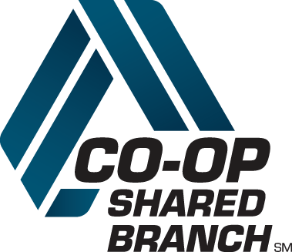
You can find a convenient shared branch location near:
• Your travel destination
• The office
• Your shopping locale
• Your home
Every shared branch location can be used just like one of our own Your Credit Union branches. Just look for the Shared Branch name and logo to conduct a range of transactions, like:
• Deposits and withdrawals
• Transfers between accounts
• Balance inquiries
• Loan payments and advances
And best of all, there is no fee to use this service!
To find a nearby Shared Branch:
• Visit co-opcreditunions.org/locator to search for locations
• Download the app “shared branch”
• Ask a teller
• Look for the CO-OP Shared Branch logo
Thank you for becoming a part of Your Credit Union. We look forward to conveniently serving you in the future!
Your Credit Union

