October 1, XXXX
Hi Ms. Smith,
We’ve just made your account more convenient than ever!
As of October 1, we’ve added [5,600~] locations to serve you. We now have branches in all 50 states!
We did this by joining with over 1,700 other credit unions as part of the CO-OP Shared Branch Network. Now you can make deposits, withdrawals, loan payments or transfers at any Shared Branch, just like you always have at our branches. Just look for the CO-OP Shared Branch logo on participating branches.
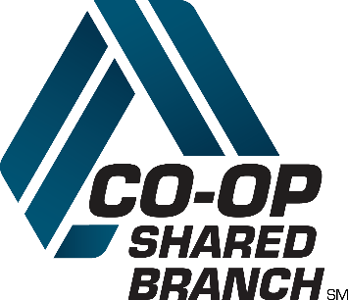
With [5,600~] locations, you’re sure to find a location close to your home, office, or school. And you’ll love the service!
To find a service center near you, visit co-opcreditunions.org/locator, call 1-888-SITE-CO-OP or download an app for Android or iPhone.
We hope you’ll visit a Shared Branch soon and see why we’re so excited about offering you this additional convenience.
Sincerely,
Your Credit Union

